Work and Energy

The concepts of work and energy are closely tied to the concept of force because an applied force can do work on an object and cause a change in energy. **Energy** is defined as the ability to do work.

Work

The concept of work in physics is much more narrowly defined than the common use of the word. **Work** is done on an object when an applied force moves it through a distance. In our everyday language, work is related to expenditure of muscular effort, but this is *not* the case in the language of physics. A person that holds a heavy object does no physical work because the force is not moving the object through a distance. Work, according to the physics definition, is being accomplished while the heavy object is being lifted but not while the object is stationary. Another example of the absence of work is a mass on the end of a string rotating in a horizontal circle on a frictionless surface. The centripetal force is directed toward the center of the circle and, therefore, is not moving the object through a distance; that is, the force is not in the direction of motion of the object. (However, work was done to set the mass in motion.) Mathematically, work is *W* = F · x, where **F** is the applied force and **x** is the distance moved, that is, displacement. Work is a scalar. The SI unit for work is the joule (J), which is newton‐meter or kg m/s 2.

If work is done by a varying force, the above equation cannot be used. Figure shows the force‐versus‐displacement graph for an object that has three different successive forces acting on it. The force is increasing in segment I, is constant in segment II, and is decreasing in segment III. The work performed on the object by each force is the area between the curve and the *x* axis. The total work done is the total area between the curve and the *x* axis. For example, in this case, the work done by the three successive forces is shown in Figure 1.

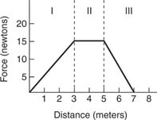

Kinetic energy is the measure of the work that an object does by virtue of its motion. Simple activities like walking, jumping, throwing, and falling involve kinetic energy. In this article, let us familiarise ourselves with the concept of kinetic energy.

|  |
| --- |
| **Table of Contents**   * [What is Kinetic Energy?](https://byjus.com/#what-is-kinetic-energy)   + [Kinetic Energy Units](https://byjus.com/#kinetic-energy-unit)   + [Kinetic Energy Examples](https://byjus.com/#kinetic-energy-examples)   + [Kinetic Energy Transformation](https://byjus.com/#kinetic-energy-transformation) * [Kinetic Energy Formula](https://byjus.com/#kinetic-energy-formula)   + [Kinetic Energy Equation Derivation](https://byjus.com/#kinetic-energy-derivation)   + [Kinetic Energy: a scalar or a vector?](https://byjus.com/#kinetic-energy-a-scalar-or-vector)   + [Kinetic Energy Calculation](https://byjus.com/#kinetic-energy-calculation) * [Kinetic Energy Types](https://byjus.com/#kinetic-energy-types)   + [Radiant Energy](https://byjus.com/#radiant-energy)   + [Thermal Energy](https://byjus.com/#thermal-energy)   + [Sound Energy](https://byjus.com/#sound-energy)   + [Electrical Energy](https://byjus.com/#electrical-energy)   + [Mechanical Energy](https://byjus.com/#mechanical-energy) * [Overview of Kinetic Energy](https://byjus.com/#kinetic-energy-overview) * [Difference Between Kinetic and Potential Energy](https://byjus.com/#difference-between-kinetic-potential-energy) * [Frequently Asked Questions – FAQs](https://byjus.com/#faqs) |

## What is Kinetic Energy?

To accelerate an object, we have to apply force. To apply force, we need to do work. When work is done on an object, energy is transferred, and the object moves with a new constant speed. We call the energy that is transferred kinetic energy, and it depends on the mass and speed achieved.

**The kinetic energy definition in Physics is given as:**

Kinetic energy of an object is the measure of the work an object can do by virtue of its motion.

Kinetic energy is a scalar quantity, and it is entirely described by magnitude alone.

### Units of Kinetic Energy

* The SI unit of kinetic energy is Joule which is equal to 1 kg.m2.s-2.
* The CGS unit of kinetic energy is erg.

### Kinetic Energy Examples

* A truck travelling down the road has more kinetic energy than a car travelling at the same speed because the truck’s mass is much more than the car’s.
* A river flowing at a certain speed comprises kinetic energy as water has a certain velocity and mass.
* The kinetic energy of an asteroid falling towards earth is very large.
* The kinetic energy of the aeroplane is more during the flight due to its large mass and speedy velocity.

### Kinetic Energy Transformation

Kinetic energy is transferred between objects and can be transformed into other forms of energy. Yo-Yo is a great example to describe the transformation of kinetic energy. While beginning to play with it, one starts by letting it rest in hand; at this point, all the energy is stored in the ball in the form of potential energy. Once the person drops the yo-yo, the stored energy is transformed into kinetic energy, the energy of movement. Once the ball reaches the bottom of the yo-yo, all the energy is converted to kinetic energy.

#### Similar Reading:

|  |  |
| --- | --- |
| [Scalar quantity](https://byjus.com/physics/scalars-and-vectors/) | [Potential energy](https://byjus.com/physics/potential-energy/) |

## The Formula for Kinetic Energy

The kinetic energy equation is given as:

$$\begin{aligned}W=m.a.d \\ \\ =m.d.\frac{v_{f}^{2}-v_{i}^{2}}{2d} \\ \\ =m.\frac{v_{f}^{2}-v_{i}^{2}}{2d} \\ \\ =\frac{1}{2}.m.v_{f}^{2}-\frac{1}{2}.m.v_{i}^{2}\end{aligned}$$

��=12��2

Where KE is the kinetic energy, m is the body’s mass, and v is the body’s velocity.

### Deriving Kinetic Energy Equation

Kinetic energy equation can be obtained by the basic process of computing the work (W) that is done by a force (F). If the body of mass m was pushed for a distance of d on a surface by applying a force that’s parallel to it, then the work done would be:

�=�.�=�.�.�

The acceleration in this equation can be substituted by the initial (vi) and final (vf) velocity and the distance. This we get from the kinematic equations of motion.

�=�.�.�=�.�.��2−��22�=�.��2−��22�=12.�.��2−12.�.��2

Simplifying the equation further, we get

�.�=12��2

Alternately, one can say that the total work that is done on a system is equivalent to the change in kinetic energy. This statement is equated as follows:

����=Δ�

This equation is known as the [work-energy theorem](https://byjus.com/jee/faq-jee-work-energy-theorem/) and has large applications even if the forces applied vary in magnitude and direction.

**Read More:** [Derivation Of Kinetic Energy](https://byjus.com/physics/derivation-of-kinetic-energy/)

### Is Kinetic Energy a Vector or a Scalar Quantity?

In the expression, we see that velocity (v) is squared. We know that the square of a vector quantity is a scalar, and we also know that mass is a scalar quantity. Therefore, kinetic energy is a scalar quantity.

### Kinetic Energy Calculation

**1. Calculate the kinetic energy of a 200 kg object that is moving at a speed of 15 m/s.**  
Solution:

The kinetic energy of the body can be calculated using the following equation:

��=12��2

Substituting the values in the above equation, we get

��=12(200��)(15�/�)2

��=45000���45��

**2. Calculate the mass of the object moving at a speed of 40 m/s and having a kinetic energy of 1500 J.**  
Solution:

Rearranging the kinetic energy equation, we get

�=2���2

Substituting the values in the above equation, we get,

�=2×1500402=1.87��

## Types of Kinetic Energy

There are five types of kinetic energy: radiant, thermal, sound, electrical and mechanical. Let us look at some of the kinetic energy examples and learn more about the different types of kinetic energy.

### Radiant energy

Radiant energy is a type of kinetic energy that is always in motion travelling through medium or space. Examples of radiant energy are:

* Ultraviolet light
* Gamma rays

### Thermal energy

Thermal energy, known as heat energy, is generated due to the motion of atoms when they collide with each other. Examples of thermal energy are:

* Hot springs
* Heated swimming pools

### Sound energy

The vibration of an object produces sound energy. Sound energy travels through the medium but cannot travel in a vacuum as there are no particles to act as a medium. Examples of sound energy are:

* Tuning fork
* Beating drums

### Electrical energy

Electrical energy is obtained from the free electrons that are of positive and negative charge. Examples of electrical energy are:

* Lightning
* Batteries when in use

### Mechanical energy

The sum of kinetic energy and potential energy is known as mechanical energy, which can neither be created nor be destroyed but converted from one form to another. Examples of mechanical energy are:

* Orbiting of satellites around the earth
* A moving car

## What is Potential Energy?

As we know, an object can store energy due to its position. In the case of a bow and an arrow, when the bow is drawn, it stores some amount of [energy](https://byjus.com/physics/energy/), which is responsible for the kinetic energy it gains when released.

Similarly, in the case of a spring, when it is displaced from its equilibrium position, it gains some amount of energy which we observe in the form of stress we feel in our hands upon stretching it. We can define potential energy as a form of energy that results from the alteration of its position or state.

After understanding potential energy and potential energy definition, let us learn the formula, unit, and examples of potential energy.  
In this article, let us learn potential energy examples in detail. 

## Potential Energy Formula

The formula for potential energy depends on the force acting on the two objects. For the gravitational force, the formula is:

|  |
| --- |
| W = m×g×h = mgh |

Where,

* m is the mass in kilograms
* g is the acceleration due to gravity
* h is the height in meters

## Potential Energy Unit

Gravitational potential energy has the same units as kinetic energy: **kg m2 / s2**  
**Note:** All energy has the same units – kg m2 / s2, and is measured using the unit Joule (J).

**For more information on potential and kinetic energy, watch the below videos:**

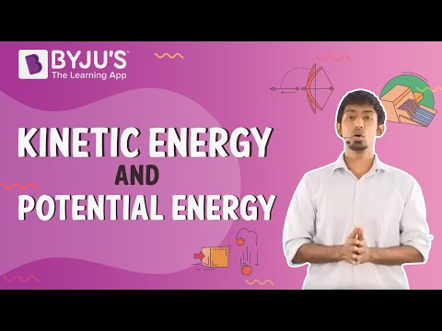

9,92,209

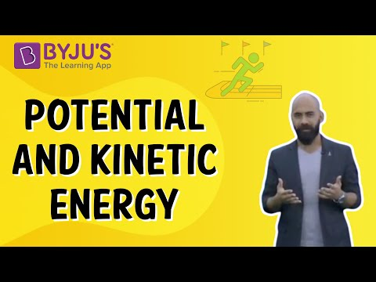

11,764

**You may want to check out the following related links**

* [Spring Potential Energy](https://byjus.com/physics/potential-energy-spring/)
* [Kinetic Energy](https://byjus.com/physics/kinetic-energy/)
* [Difference Between Kinetic and Potential Energy](https://byjus.com/physics/kinetic-and-potential-energy-difference/)

## Types of Potential Energy

Potential energy is one of the two main forms of energy. There are two main types of potential energy, and they are:

* Gravitational Potential Energy
* Elastic Potential Energy

### Gravitational Potential Energy

The gravitational potential energy of an object is defined as the energy possessed by an object that rose to a certain height against gravity. We shall formulate gravitational energy with the following example.

* Consider an object of mass = m.
* Placed at a height h from the ground, as shown in the figure.

As we know, the force required to raise the object equals m×g, that is, the object’s weight.

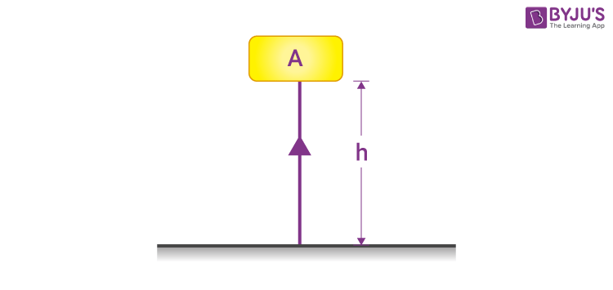

As the object is raised against the force of gravity, some amount of work (W) is done on it.

Work done on the object = force × displacement.

So,

|  |
| --- |
| W = m×g×h = mgh |

***Above is the potential energy formula.***

As per the [law of conservation of energy](https://byjus.com/physics/law-of-conservation-of-energy/), since the work done on the object is equal to m×g×h, the energy gained by the object = m×g×h, which in this case is the potential energy E.

**E** of an object raised to a height h above the ground = **m×g×h**

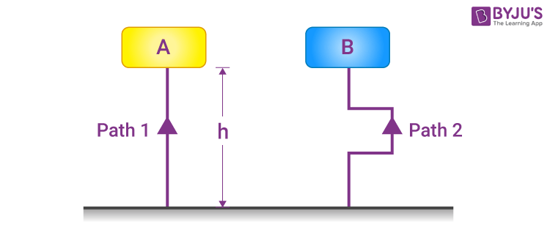

It is important to note that the gravitational energy does not depend upon the distance travelled by the object, but the displacement, i.e., the difference between the initial and the final height of the object. Hence, the path along which the object has reached the height is not considered. In the example shown above, the [gravitational potential energy](https://byjus.com/jee/gravitational-potential-energy/) for both blocks A and B will be the same.

### Elastic Potential Energy

Elastic potential energy is stored in objects that can be compressed or stretched, such as rubber bands, trampolines and bungee cords. The more an object can stretch, the more elastic its potential energy is. Many objects are specifically designed to store elastic potential energy, such as the following:

* A twisted rubber band that powers a toy plane
* An archer’s stretched bow
* A bent diver’s board just before a diver dives in
* The coil spring of a wind-up clock

An object that stores elastic potential energy will typically have a high [elastic limit](https://byjus.com/physics/elastic-limit/). However, all elastic objects have a threshold to the load they can sustain. When deformed beyond the elastic limit, the object will no longer return to its original shape.

Elastic potential energy can be calculated using the following formula:

�=12��2

Where,

* *U* is the elastic potential energy
* *k* is the spring force constant
* *x* is the string stretch length in m

## Potential Energy Examples



Stones sitting on an edge of a cliff possess potential energy. The potential energy will be converted if the stones fall to kinetic energy.



Tree branches high up the tree have potential energy because they can fall to the ground.



The food that we eat has chemical potential energy. Our body digests this potential energy and provides the necessary energy for bodily functions.



The chemical potential energy of a firecracker is released when the fuse of the firecracker is lit.

### Potential Energy Practice Question:

**Q1: What will be the gravitational potential energy of a ball of mass 1 kg when it is raised to 6 m above the ground. (g = 9.8 m s–2)**

**Solution:**  
Here, the mass of the object (m) = 1 kg,  
Displacement (height) (h) = 10 m,  
Acceleration due to gravity (g) = 9.8 m s–2.  
Hence, Potential energy (P) = m×g×h = 1 kg × 9.8 m s–2 × 10 m = 98 J.

Hope you understood in detail what is potential energy and what potential energy definition, examples, and types are. Stay tuned to BYJU’S – The Learning App to learn about various science and maths concepts.